Design Philosophy of Project 114
Stephen M. Hollister February, 2015

The goal of project 114 is to demonstrate and set up a process for developing a flexible and integrated set of tools for marine design calculations in a market that is not properly supported by commercial software development. This is done using the basic building blocks of Calculations (Calcs), Graphical User Interfaces (GUIs), and data files (DBs). (See the article on the basic building blocks of Project 114 for more details). This paper will discuss the philosophy behind this approach.
The classic systems analysis approach to complex computer systems development is top-down – Analysis, Design, Code, and then Test. The analysis stage normally includes an examination of “use cases” - scenarios of the different tasks and processes. The assumption of top-down development is that the end result and use cases are knowable beforehand. In the area of general marine calculations, this is not possible. The goal here is to be able to handle any new use case in the future. This is a tall order.
Another approach to systems development is one that is bottom-up, defining a prototype system where learning can be done while building a usable and testable system. Top-down pre-analysis can fail when the system to be developed is complex and new, and it can also result in “analysis paralysis”. However, prototyping has its own pitfalls. One can spend a lot of time developing a real system before finding out that basic assumptions were wrong and that the whole thing has to be scrapped. In the case of Project 114, the goal is to spend enough time getting the basic building blocks correct beforehand, and to define building blocks that are independent and powerful. This approach is driven by the following goals:
An open system
A low learning curve
Separation of skills
Flexibility of components
Long "shelf life" for software
User customization
Reuse of legacy code
Organizational agreement of data and file formats

The key components are the low learning curve and the power and flexibility of the basic building blocks.

The basic needs of marine designers are calculations – input, calc, and output. Normally, programs are created by those (or a team) who know both the details of the naval architecture calculations and the details of programming what are now becoming complex GUI tools. It’s rare that these skills appear in one person, but the combination of the two needs (in each program) increases the cost and complexity of providing solutions. The end result is a need that isn’t filled for the small marine market. The goal of Project 114 is to change this approach to reduce costs and complexity, thereby giving everyone a chance to contribute to a flexible and integrated solution. This requires a technical solution and organizational support.
The technical solution is based on a new paradigm of software development and the powerful basic building blocks of Calcs, GUIs, and DBs. The key change is to split calculations from their GUI front end. The building block article provides more details of this approach.
Organizational support will come from SNAME in various ways, the most important of which is support of common data definitions and data file formats. This will prevent the development of calculation tools that don’t work well together. Support will also come from visibility and outreach, including the area of education.
Each of the goals above are discussed below in terms of how Project 114 will meet their needs.

Open System
While calculations may be proprietary and in EXE or DLL forms, they are defined in such a way that anyone else can use them for their own custom applications. Calculations are independent of any particular GUI front end. Also, using a spreadsheet as a GUI front end is open for everyone to examine and all macro code is open to view and modify. Users can create their own spreadsheet that launches one or more of any available calculation engine and then add in their own code. It is hoped that many will share their spreadsheet solutions.
Users will also be encouraged to share tools based on standards for data files and variables. One can have an open system, but it takes simplicity and connectivity standards to make it work well. An open system is also required for a small marine market that cannot be fully served by independent software developers.

Low Learning Curve
This starts with the simplicity of the separate calc engines. They read a simple text file, do the calculations, and they write a simple text file. One can open the text file with Notepad and examine the input or output. In most cases, output will be in comma separated form that can be opened up and displayed automatically with a spreadsheet just by double clicking on the file. The user does not have to know anything about any other part of the system. If users want to do one calculation, then all they have to do is read the documentation for that one calculation program. In most many cases, users have to understand a complex GUI even when they want to do just one calculation. The benefit of separate calculations is that one can easily create several custom GUI front ends, some with more default values and simple input. In many traditional combination GUI/Calc cases, as the program gets more powerful, the complexity of the GUI increases. This is a major problem for many programs; simple things are not simple.
The next level of understanding involves how to use spreadsheet tools to perform multiple calculations in a row, perhaps changing one variable and graphing the results. After that, one might venture into customizing a GUI front end by adding in formulas based on the results of the calculation. If those calculations are important or large enough, they could be recreated as a separate calc engine that others could use.

Separation of Skills
A big advantage for splitting the calcs from the GUI is that it separates the programming skill required for the two parts. Many naval architects can program calculations but do not have the skills needed for custom GUI programming with software such as Visual Basic or Qt. Also, most designers know how to use spreadsheets, and the skills (macros) needed for launching complex external calculations are very simple. The split of calculations also makes programming easier than all-in-one spreadsheet solutions when the calculations get more complex. There are many cases where calculations are so complex that they could never be done inside of a spreadsheet.

Flexibility of Components
Separate calc engines can be used by anyone else. They are not tied to just one GUI. They can be mixed and matched. They can also be in EXE or DLL forms for use in different situations and with different types of programs. Spreadsheet GUI blocks are open for anyone to see or customize, so designers can create their own custom GUI for someone else’s calc engine.
Also, using a spreadsheet for the GUI offers their full range of tools for analysis and integration with programs like Word or PowerPoint.
Data files and databases will be defined from the bottom-up, built up from the simple text files used for each calculation. It will not be a complex system imposed from the top down. The tradeoff is simplicity and flexibility versus integration and seamless operation. However, integration will be encouraged by standards and the input and support of SNAME members.

Long "Shelf Life" for Software

When calculations are split from a GUI front end, they can be written in any computer language and can be tested and validated separately. They will not change when technology changes, as when DOS changed into Windows. Owners of the calculations might provide updated versions, but the old versions will not go away and make their GUI front ends obsolete. GUI front ends using spreadsheets will also not go away (easily) because there is a great need for backward compatibility for all industries. Spreadsheets are a very mature technology.

User Customization
It is not possible (market-wise) for software developers to create one program that can do everything. For example, a program cannot provide all hydrostatics and stability calculations for all rules like ABS, USCG, and Lloyds. It would be too complex and costly even if it could be done. However, a user could combine an existing hydro/stable calc engine with a custom spreadsheet front end to solve new or specific requirements. Common spreadsheets have many advanced analysis and integration tools. A user could add in custom graphs and tie them to standard Word files. If designers deal with a specific type of vessel that needs to go through the same sort of stability approval calculations, a custom process could be designed so that spreadsheet results (tabular data and graphs) could be automatically fed into a Word document in a form that is ready to be submitted. All of this is possible when calculations are separated from any particular GUI.

Reuse of legacy code
With separate calculations (EXE or DLL), it will be easier to revive important legacy code. They can be recreated in any language and need not be converted to a language that is best for a GUI. It should be much easier to strip off old GUI code to create stand-alone calculations. Then, adding on a standard spreadsheet front end will be a simple task.

Organizational agreement of data and file formats
At the lowest level, everything is centered around the needs of a single calculation engine (EXE). It has certain inputs and certain outputs using simple text files. To ensure that the many design calculation pieces of this open system puzzle fit together, one needs organizational support and agreement. This will be provided by a committee of SNAME members. This can be as simple as agreeing upon the use of labels like VCG rather than KG, but it can also take the form of deciding on a standard text file definition of hull stations for use with hydro/stable calculations. This doesn’t mean that programs which use polyhedra for those calculations are not allowed. It will never be an either/or situation. However, an open system may require numerous format translators to get the pieces to connect smoothly. The goal of this committee will be to minimize unnecessary mismatches and differences in data definitions.
At the lowest calc engine level, text files will be used because they are the simplest to learn and one can use Notepad for editing values. Formats such as XML are avoided because of added complexity and programming costs. There are also questions about the technical life of XML formats. XML formats may go away at some point, but not text files.
The next layer up from the text files relates to integration and collection of all data for one particular hull geometry using a spreadsheet. This will optionally include information on each operating condition for the vessel. Open spreadsheet macros will be provided to transfer design data between specific hull spreadsheet “databases” and spreadsheet GUIs. One can still run a calc engine by entering all of the input, but there will be an option (macro) that will pre-load design input from a spreadsheet database and an option (macro) to output results to the database.
These data formats will be geared towards conceptual and preliminary design and the calculations that need that data. There is no intent to compete with the detail design needs or geometry control offered by large scale computer-aided design software. However, the transition between preliminary design data and calculations and detailed design data and calculations will have to be addressed. In the case of hull surface design, NURB surfaces can evolve from conceptual design tools to detailed design CAD software. The same cannot be said for things like compartmentation geometry and damaged stability calculations. There are currently no tools for going from conceptual design compartment shapes to detailed CAD arrangements definition. That will have to be addressed at some point in the future.

Additional Benefits
Breaking the one-to-one connection between calculations and a GUI has additional powerful benefits. One can have multiple custom GUIs for one calculation depending on the needs of the user, and more importantly, one user-defined GUI can launch several different calc engines in a row. One can even have the spreadsheet GUI iterate over a sequence for different input variables. Going one step further, the user could define a merit function and the spreadsheet could search for an optimum value. For example, one spreadsheet could launch a hydro/stable calculation followed by a resistance calculation followed by a powering calculation, where the results of one calculation are automatically fed in as input to the next calculation. After the final calculation, the user could feed the results to a merit function (perhaps in that spreadsheet) to calculate a value. This calculation sequence could be iterated in the form of an optimization search. For multiple variable optimization searches, one might use an external calc engine to determine the next search vector of independent variables.
In addition to calculations based on one hull shape, “calc” engines could be built to perform hull variation (“Lackenby” code already exists for hull variation of station definitions) and one could be added to a GUI calculation engine and merit function sequence. This would allow for user-defined automatic hull variation and optimization.

Prototype Status
A prototype calc engine for hydrostatics/stability based on a traditional hull station definition format has been completed. This is a calculation that is too large to fit inside of a spreadsheet. A spreadsheet GUI has been built that collects the input, launches the external hydro calculation, and then automatically brings the results back into the spreadsheet to fill other worksheets. The calculations are done immediately and the user cannot tell that the calculations are done in another program. The prototype can also repeat the calculation using new input and place the results in adjacent columns. This process can be repeated and the any results plotted using the wide variety of spreadsheet graphing tools.
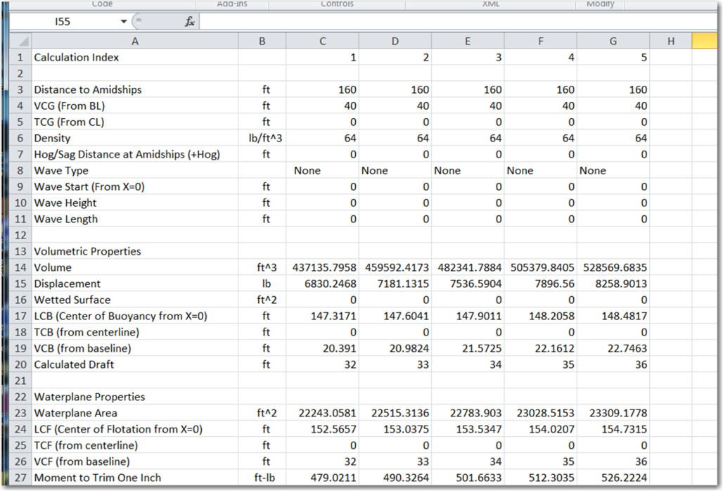
This is a snapshot of a results worksheet showing different values for a range of user-selected drafts.

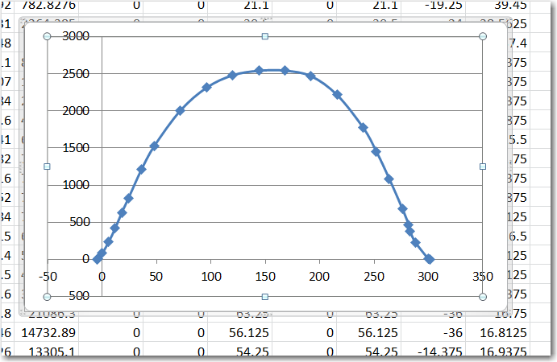
This is a plot of the sectional area curve for one of the draft conditions.
It would be an easy task for a user to add in any special ABS, USCG, ISO, or other stability calculation to each results column. The user might then vary VCG and plot the results of that custom calculation to find the max VCG value for that rule.

Conclusion
There are fewer risks involved with designing large scale computer systems using a bottom-up approach. For this project, the stand-alone calcs will never become obsolete even if there are big issues with using a spreadsheet as a common GUI front end. One can still add a DLL version of the calculations into a custom-built GUI front end, if desired. Calcs will also have a long shelf life and will be less likely to become obsolete when technology changes. However, it’s unlikely that there will be technology or obsolescence issues with spreadsheets. Students will still learn how to use spreadsheets in middle school and they will continue to be an important calculation/report integration tool.
There will be on-going issues with defining common data file and database formats that meet the needs of all calculations. There may also be issues with the integration of this data with general purpose CAD design tools. One risk is that some of the commercial integrated CAD tools will eventually push back into and conflict with the tools developed by this project. However, the tools of Project 114 should be flexible enough to meet these needs. The most visible example of this is the transition of compartment and tank geometry for stability and loading calculations into an arrangements definition required by detailed design CAD programs.
Finally, there is the need for reaching a critical mass of use. The key to success in this area is outreach, ease of learning, and useful tools.

